ECE Laboratory

**DREXEL UNIVERSITY**

**To: Dr. Peters**

**From: Ehi Simon**

**Re: ECE 304 Lab 3 - Clients, Servers, and HTML**

**PURPOSE:**

The purpose of this week’s lab is to perform rudimentary remote monitoring and control using a smart phone and/or laptop through the use of the Bluetooth and Bluetooth Low Energy (BLE) protocols. Using Bluetooth and BLE will make it easy to perform on-demand monitoring and control.

**Discussion:**

*Fig. 1. Circuit Connection for Project 2*

The circuit for the lab was built like the one above. It consists of 2 330 resistors, a red LED, a blue LED, a BME280 Environmental Sensor, an Adafruit BNO085 IMU, and an ESP32S microcontroller.

**Exp3.cpp**

In my main.cpp file, I initialized the multiple libraries that were needed for the sensors to work and provide readings. I also included libraries to get the ESP32 to connect to AP, STA, or both for the Wi-Fi. The LEDs are defined, the sea level reference pressure is defined and the BNO08X chip is reset. The BME object is created, the soft AP SSID & password are set, as well as the network SSID and password. IP Address details are put in for AP mode, and then the web server is opened on port 80. This can all be found in the figure below:

*Fig. 2. Figure Showing Initialization of Libraries and Variable Definitions*

*Fig. 3. Figure Showing SendHTML Function*

The figure above shows the HTML code that was inserted into my exp3.cpp file in the code. I create the webpage, give it a background color, give it a title, a heading, and I create two tables that contain the readings from the BME 280 sensor and the readings from the BNO. It also has a checkbox to toggle the blue LED, as well as a form to choose a value for the red LED.

*Fig. 4. Figure Showing Functions to Calculate Yaw, Pitch, and Roll*

The figure above shows functions that were needed, and implemented to calculate the yaw, pitch, and roll.

The figure below shows the handle_OnConnect() function. This function assigns readings from the sensors to variables that are used in the HTML code to be displayed on the webpage. It also prints them out to the serial terminal based on the LED values that the user enters on the webpage. This function toggles the blue LED after receiving info from the webpage, changes the intensity of the red LED. It calls the SendHTML function that was seen earlier in figure 3 with arguments converted to strings from the sensor readings. This is how the html webpage is created.

*Fig. 5. Figure Showing handle_OnConnect Function*

The figure below shows the setup function of the file. This setup function does more than those in previous projects. It sets the LED pin modes. It also initializes the BME280 sensor and the BNO08X chip. It then prompts the user to answer which mode it wants to work with. After the user enters a value, it uses if statements to choose the Wi-Fi mode based on the answer and initialized that Wi-Fi mode.

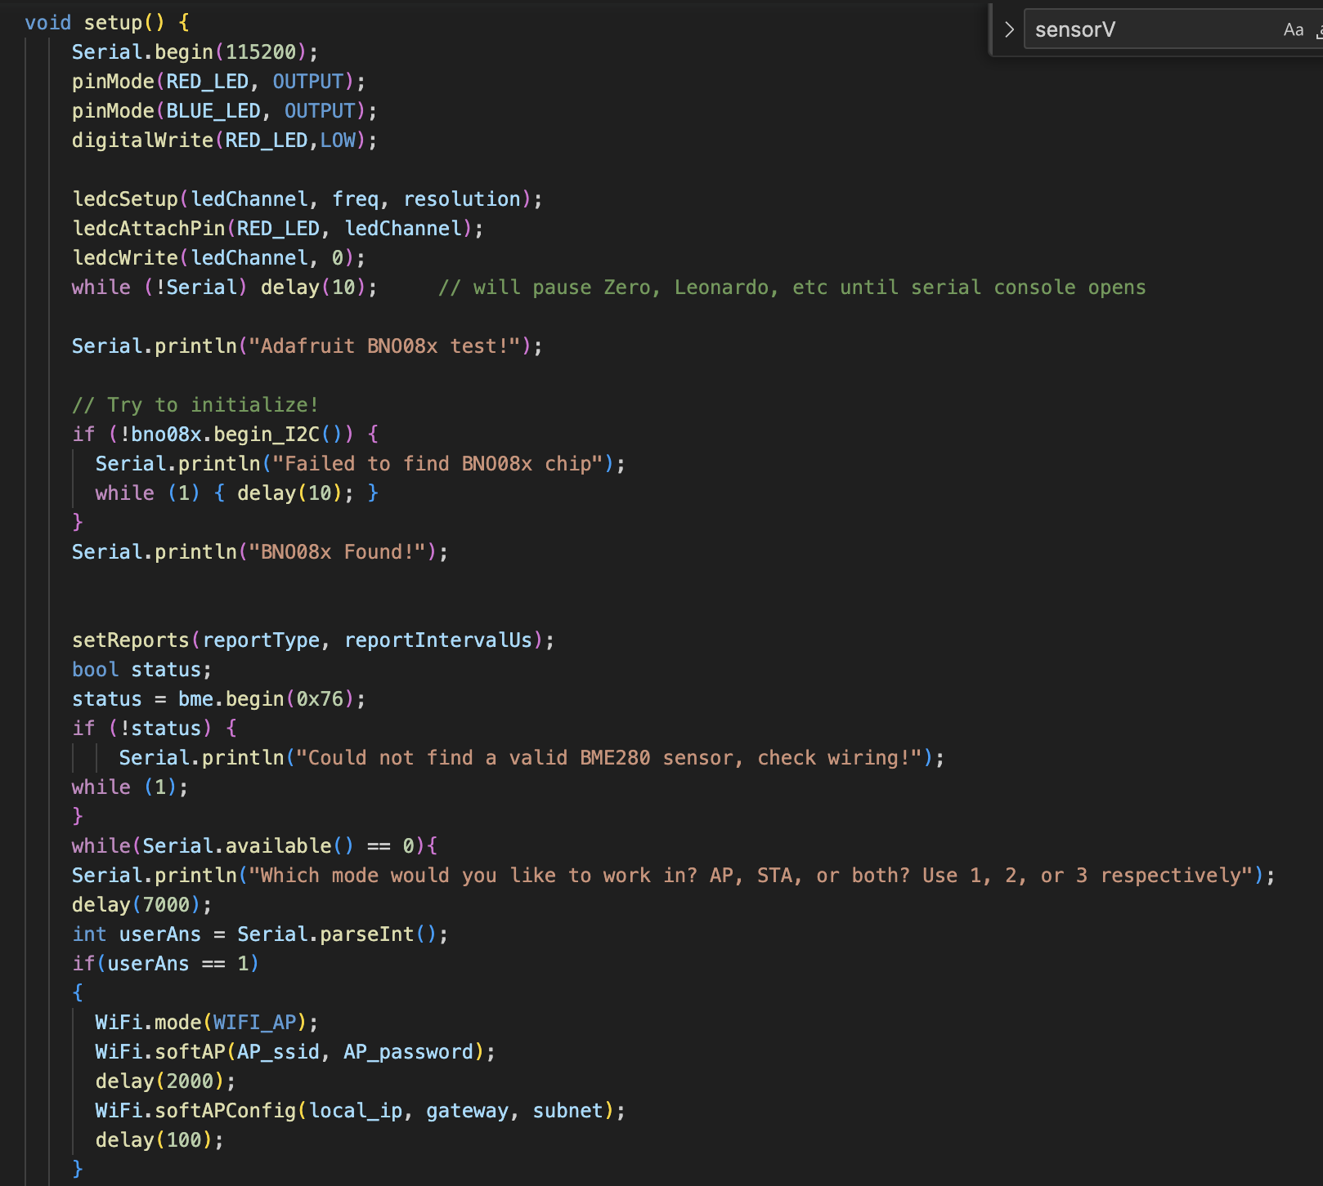

*Fig. 6. Figure Showing Setup Function*

After the if statements, the function turns on the server using our handle_OnConnect function and begins it. It then prints the HTTP Address and the local IP address.

*Fig. 7. Figure Showing Continuation of Setup Function*

The loop function is made up of one line only and that can be seen in the figure below.

*Fig. 8. Figure Showing Loop Function*

The final result was a webpage as well as output on the serial monitor. It can be seen in the figures below:

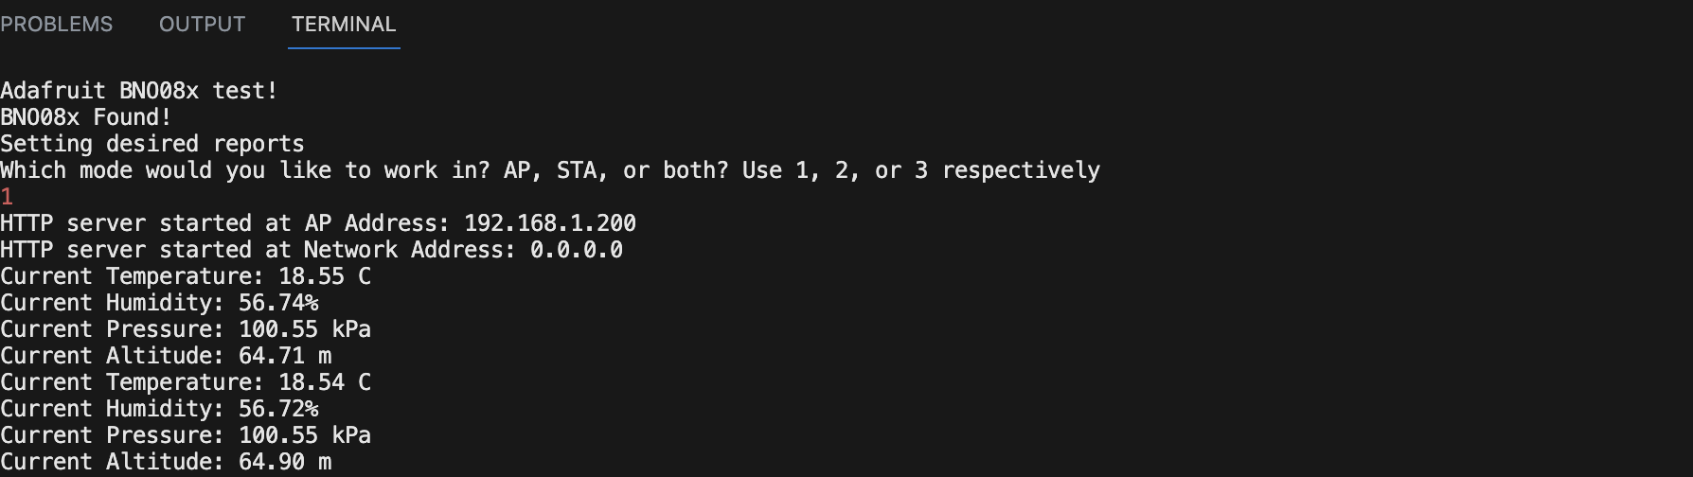

*Fig. 9. Figure Showing Output on Serial Monitor*

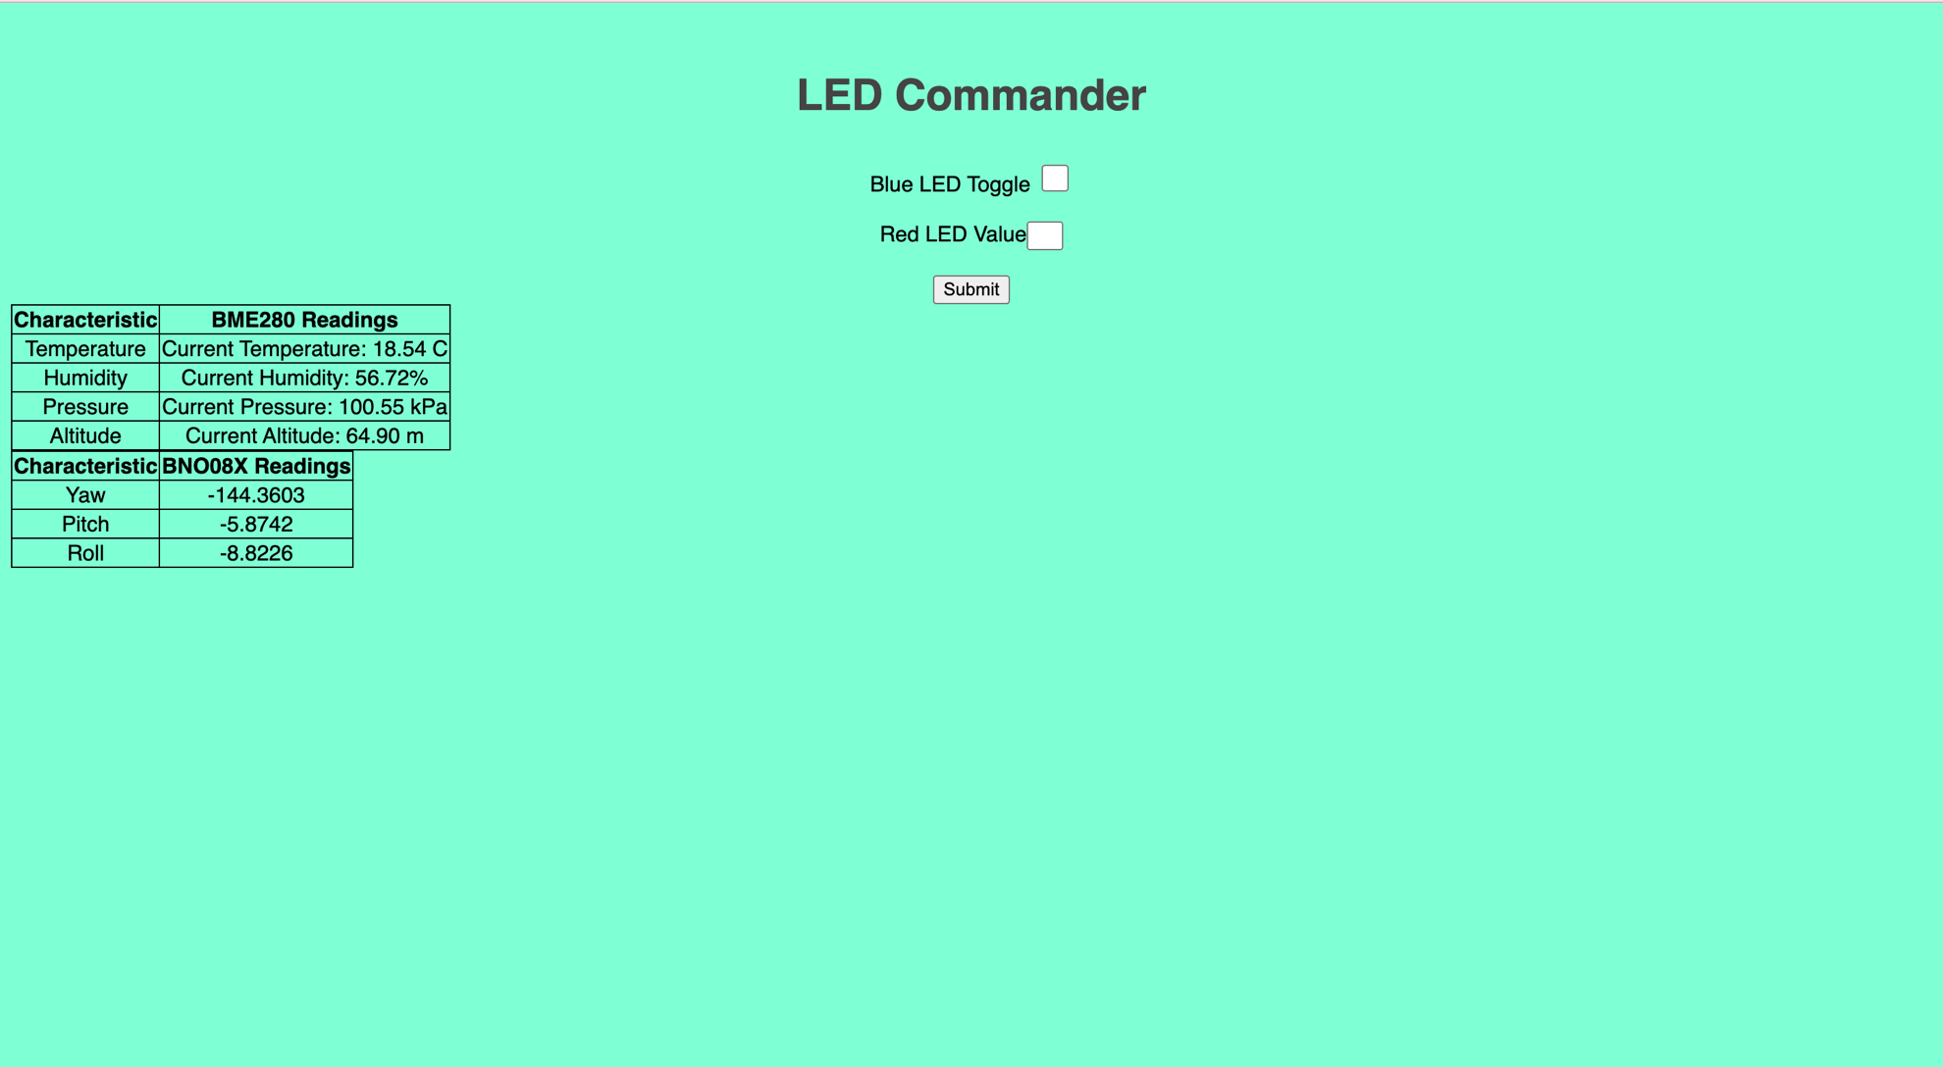

*Fig. 10. Figure Showing Output on Webpage*

**Conclusion**

In this experiment, I learned about the different Wi-Fi modes and how ESP32 connects to them. I learnt how to incorporate HTML into my cpp file to build a webpage, and I polished my HTML skills.